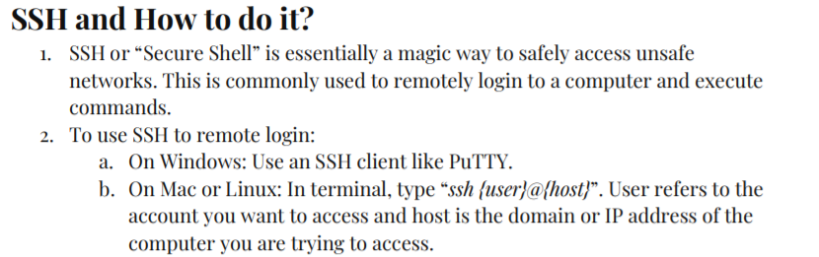

For more in-depth understanding of SSH, please follow this link: <https://www.hostinger.com/tutorials/ssh-tutorial-how-does-ssh-work>

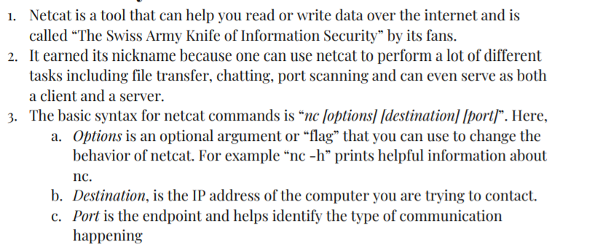

To understand how to use netcat, follow this link:

<https://www.poftut.com/netcat-nc-command-tutorial-examples/>